# 

# **SMB Lab Pre Lab Company Summary Report**

## **Section 1: Company Information**

* Company Name: {{Company Name}}
* Email: {{Email}}
* Founder/CEO of company: {{Founder Story}}
* Primary Contact Name: {{Primary Contact Name}}
* Role: {{Role}}
* Phone: {{Phone}}
* LinkedIn: {{LinkedIn}}
* Website: {{Website}}
* Company Address: {{Company Address}}
* Year Established: {{Year Established}}
* Company Type: {{Company Type}}

## **Section 2: Company Overview**

* Mission: {{Mission}}
* Products/Services: {{Products/Services}}
* Differentiators: {{Differentiators}}
* Industry: {{Industry}}
* Stage: {{Stage}}
* FT Employees: {{FT Employees}}
* PT Employees: {{PT Employees}}
* Revenue: {{Revenue}}
* Profitability: {{Profitability}}

## **Section 3: Team**

* Team Bios: {{{{Team Bios}}}}

## 

## **Section 4: Challenges & Goals**

* Help Areas: {{Help Areas}}
* Main Challenge: {{Main Challenge}}
* CEO Concerns: {{CEO Concerns}}
* Goals: {{Goals}}
* Worked with Consultants: {{Worked with Consultants}}

## **Section 5: Operations**

* Supply Chain Model: {{Supply Chain Model}}
* Supply Chain Details: {{Supply Chain Details}}
* Sales Channels: {{Sales Channels}}
* Customer Segments: {{Customer Segments}}
* Customer Persona: {{Customer Persona}}
* Top Markets: {{Top Markets}}
* Competitors: {{Competitors}}
* Technology Stack: {{Technology Stack}}

## **Section 6: Financial Snapshot**

* Last Fiscal Year
  + Last Year Revenue: {{Last Year Revenue}}
  + Last Year COGS: {{Last Year COGS}}
  + Last Year OpEx: {{Last Year OpEx}}
  + Last Year Net Income: {{Last Year Net Income}}
  + Last Year Cash: {{Last Year Cash}}
* Year To Date
  + YTD Revenue: {{YTD Revenue}}
  + YTD COGS: {{YTD COGS}}
  + YTD OpEx: {{YTD OpEx}}
  + YTD Net Income: {{YTD Net Income}}
  + YTD Cash: {{YTD Cash}}

## **Section 7: Legal and IP**

* Own IP: {{Own IP}}
* IP Details: {{IP Details}}
* Legal Issues: {{Legal Issues}}
* Legal Details: {{Legal Details}}

## **Section 8: Impact & Values**

* Impact Areas: {{Impact Areas}}
* SDG Alignment: {{SDG Alignment}}
* SDG List: {{SDG List}}

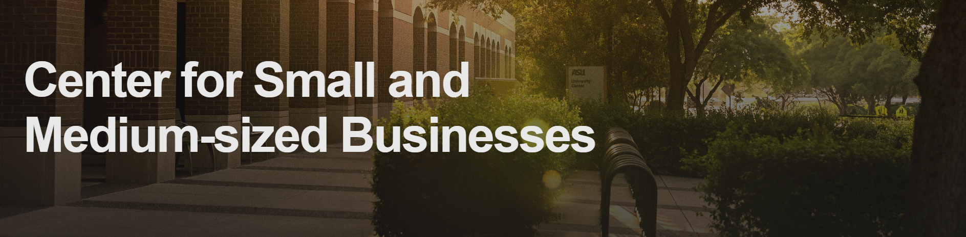

## **Section 9: Engagement Expectations** (Internal CSMB Use only)

* Project Timeline: {{Project Timeline}}
* Involvement Level: {{Involvement Level}}
* Student Engagement: {{Student Engagement}}
* Success Definition: {{Success Definition}}

## **Section 10: Consent** (Internal CSMB Use only)

* Consent & Use: {{{{Consent & Use}}}}
* Signed: {{{{Digital Signature}}}},
* Date: {{{{Date}}}}